42.29: 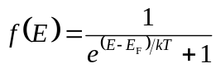
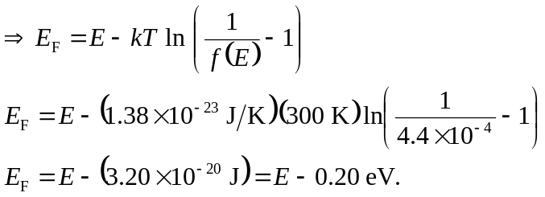
So the Fermi level is 0.20 eV below the conduction band.

